**Sample Template of Extend Abstracts in Double Column Format for Proceedings Publication**

First A. Author, Second B. Author, Jr., Third C. Author*

Affiliation1, Address, City, Country, E-mail

*b*Affiliation1, Address, City, Country, E-mail

*c*Affiliation1, Address, City, Country, E-mail

*d*Affiliation1, Address, City, Country, E-mail

**Abstract- A brief abstract is required. The maximum length of the abstract is not more than 150 words. The abstract should preciously describes the objective of the study, important findings and most important conclusions. Any references or abbreviations should be avoided.**

*Keywords*— MBBR; composite wastewater; mathematical modeling; monads’ kinetic; process design.

**I. Introduction**

Origin and Relevance of the topic related to the conference theme. A very brief historical background with important milestones has been achieved so far avoiding any comprehensive literature review or a summary of the previous published results. State the objective of the study.

**II. MATERIALS & METHODS**

Provide a detailed description of reagents, materials used, glassware, analytical procedure, detail schematic diagram of a experimental setup and a standard protocol for executing any experimental study. Methods has already been published in any literatures/books should be properly cited in the relevant section by a reference.

**Example of table**

|  |  |  |  |
| --- | --- | --- | --- |
| **Symbol** | **Quantity** | | **SI a** |
| Maximum | | 8.8 | 25280 |
| Minimum | | 8.3 | 4345 |
| Average | | 8.6 | 11981 |
| Maximum | | 8.8 | 25280 |
| Minimum | | 8.3 | 4345 |
| Average | | 8.6 | 11981 |
| Maximum | | 8.8 | 25280 |
| Minimum | | 8.3 | 4345 |
|  |  | |  |

**EXAMPLE of figure**

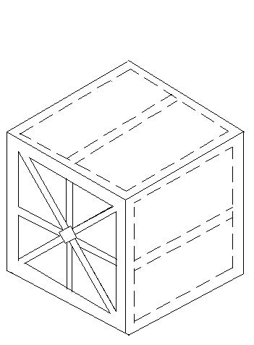

Fig. 3: Example of Figure 1

**III RESULTS & DISCUSSION**

results should be clear and concise. discussion should include the significant outcome of the results of the work. avoid extensive citations and discussion of published literature.

**IV .CONCLUSION**

The main conclusions are obtained from the experimental study results should be presented in a short paragraph. Do not include any citations or results in this conclusion section.

**Acknowledgment**

The present research work is supported under the Research fellowship programme of Ministry of Human Resource Development, Government of India

**References**

[1] H. Sun, S. Liu, S. Liu and S. Wang, “A comparative study of reduced graphene oxide modified TiO2, ZnO and Ta2O5 in visible light photocatalytic/photochemical oxidation of methylene blue,” [Applied Catalysis B: Environmental](http://www.sciencedirect.com/science/journal/09263373), [vol. 146](http://www.sciencedirect.com/science/journal/09263373/146/supp/C), pp. 162–168, March 2014.

[2] M.S. Mahmoud, J.Y. Farah and T.E. Farrag, “Enhanced removal of Methylene Blue by electrocoagulation using iron electrodes,” Egyptian Journal of Petroleum, vol. 22, pp. 211-216, 2013.

[3] C.-H. Weng and V. Huang, Application of Feo aggregate in ultrasound enhanced advanced Fenton process for decolorization of methylene blue,” [Journal of Industrial and Engineering Chemistry](http://www.sciencedirect.com/science/journal/1226086X), vol. 28, pp. 153-160, August 2015.

[4] S. Ledakowicz, M. Solecka and R.Zylla, “Biodegradation, decolourization and detoxification of textile wastewater enhanced by advanced oxidation processes,” J. Biotech., vol. 89, pp. 175-184, 2001.

[5] K. Esumi and S.Yamamoto, “Adsorption of Sodium dodecyl sulfate on hydrotalcite and adsolubilization of 2-naphthol,” Col. And Sur. A: Physicochem.l & Engg. Asp., vol. 137, pp. 385-388, 1998.

**AUTHORS CAN USE THIS FORMAT FOR PAPERING THEIR MANUSCRIPT BY REMOVING ALL THE TEXT AS GIVEN HERE.**

**EXTENDED ABSTRACT SHOULD NOT BE MORE THAN 2 PAGES.**

**Instructions to Authors**

**Paper Size: US Letter format Page margins are 1.78 cm top and down and 1.65 cm left and right. Each column width is 8.89 cm and the separation between the two columns is 0.51 cm. Paper Title: Times New Roman/Garamond, 22 pt., Centered, Title Case (Capitalize Each Word), Bold Authors’ Names: Times New Roman, 11 pt., Centered, Title Case (Capitalize Each Word). Type Sizes and Typefaces:. Times New Roman/Garamond is the preferred font, 10 pt.Paper Styles: Left- and right-justify the columns. Line spacing is 1.5.**